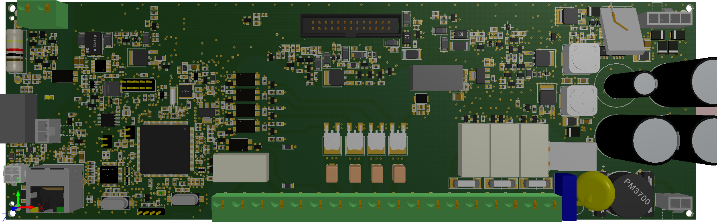
15VSP
5VS
3V3S
12VSP
15VS
15V

